# Question133 Monitor data processing-

You deploy Azure Databricks for your organization in the Microsoft Azure cloud to support development of a new big data analytics solution.  
  
You already use Azure Monitor to monitor the performance of other corporate solutions.  
  
You need to enable visualization of Azure Databricks metrics in Azure Monitor as well.  
  
Which options describe the way you can enable your strategy? To answer, select the appropriate options from the drop-down menus.

Choose the correct options

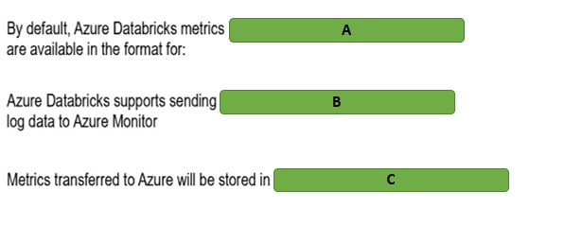

A)

1. Ganglia
2. Azure Monitor
3. Datadog

B)

1. Natively
2. Using a third-party library
3. Using the open neural network exchange (ONNX) runtime

C)

1. Azure Log Analytics workspace
2. Azure Network Watcher
3. Client’s own DB instance

# Question134 Monitor data processing-

You are managing several HDInsight clusters in your company’s Azure subscription. Your line manager asks you to enable specific monitoring tasks for HDInsight clusters.  
  
You need to choose a relevant tool for each task.  
  
Which tool should you use? To answer, select the appropriate options from the drop-down menus.

Choose the correct options

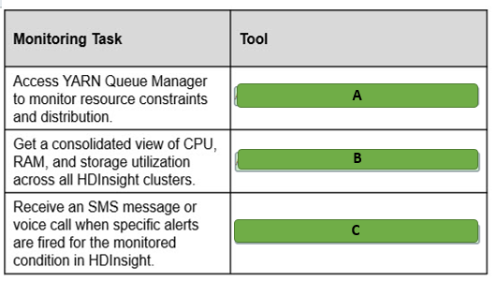

A)

Apache Ambari

Azure Monitor logs

Windows Event Viewer

Linux dmesg

B)

Apache Ambari

Azure Monitor logs

Windows Event Viewer

Linux dmesg

C)

Apache Ambari

Azure Monitor

Windows Event Viewer

Linux dmesg

# Question135 Monitor data processing-

You manage an Azure SQL Database instance that uses the Database Throughput Unit (DTU) pricing model. It has a maximum of 5 DTUs and is two gigabytes (GB) in size. You must upgrade the instance's tier if its CPU reaches 50 percent, its memory usage reaches one GB, or if its disk reads or writes per second reach 50 percent of its capacity.  
  
You need to create an alert that monitors the instance over a 12-hour period.  
  
How should you configure the alert? To answer, select the appropriate configuration values from the drop-down menus.

Choose the correct options

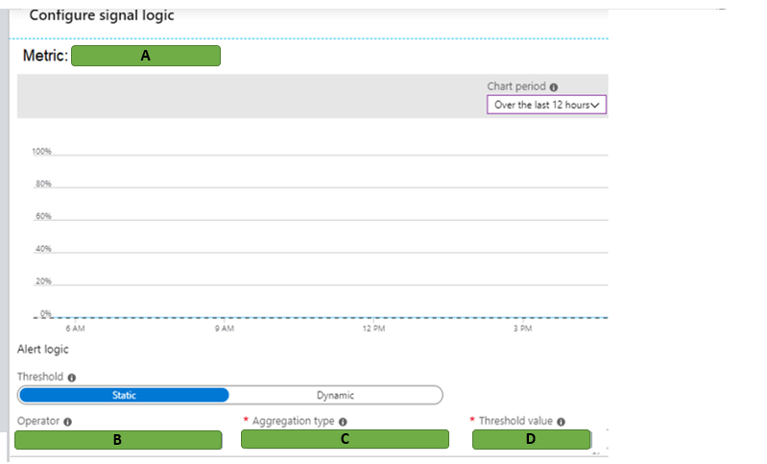

A)

1. Data space used
2. DTU Percentage

B)

1. Greater than or equal to
2. Less than

C)

1. Average
2. Minimum
3. Maximum

D)

1. 2.5
2. 50

# Question136 Monitor data processing-

You have an Azure SQL Database instance with a single database. You are enabling diagnostics logging. You want to gather information about performance recommendations, queries that are taking the longest to run, and CPU and Database Throughput Unit (DTU) limits and percentages.  
  
You need to determine which three logs to enable.  
  
Which three logs should you enable? To answer, move the appropriate logs from the list of possible logs to the answer area and arrange them in any order.

Create a list in any order

Possible logs

Logs to monitor

* DatabaseWaitStatistics
* QueryStoreWaitStatistics
* Basic metrics
* QueryStoreRuntimeStatistics
* SQLInsights

# Question137 Monitor data processing-

You are a data engineer for your company. You have an HDInsight cluster in Azure.  
  
You need to monitor the cluster for performance.  
  
What should you do?

Choose the correct answer

Create a Log Analytics workspace and use Azure Advisor.

Create a Data Lake Analytics account and use Azure Advisor.

Create a Data Lake Analytics account and use Azure Monitor.

Create a Log Analytics workspace and use Azure Monitor.

# Question138 Monitor data processing-

You are a data engineer for your company. You have an Azure Databricks account. You want to use Azure Monitor to monitor the Databricks account.  
  
You need to choose a solution for sending application metrics to Azure Monitor.  
  
Which library or tool should you use?

Choose the correct answer

Log4j

Dropwizard

Azure CLI

Powershell

# Question139 Monitor data processing-

You are a data engineer. You want to set up an alert to monitor a Stream Analytics job. You want to receive an alert when the job stops unexpectedly.  
  
You need to configure the alert.  
  
How should you configure the alert? To answer, select the appropriate configurations from the drop-down menus.

Choose the correct options

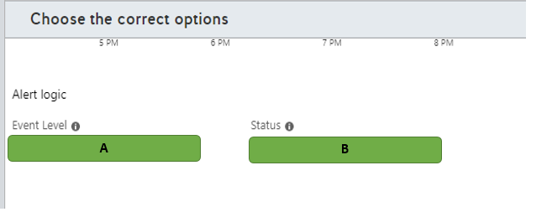

A)

1. All
2. Warning

B)

1. Failed
2. Succeeded

# Question140 Monitor data processing-

You are a data engineer. You manage an HDInsight cluster. You want to monitor the cluster's performance by using a web user interface.  
  
You need to choose the appropriate tool for monitoring.  
  
Which tool should you use?

Choose the correct answer

Azure Stream Analytics

Azure Log Analytics

Apache Ambari

Apache Spark

# Question141 Monitor data processing - D

You are a data engineer. You have an Azure Data Factory pipeline in the US East region. You realize that pipeline run-data is deleted after 45 days.  
  
You need to keep the run-data from the pipeline for longer than 45 days.  
  
What should you do?

Choose the correct answer

Configure diagnostics logs to send data to a blob storage account.

Re-create the Data Factory pipeline in the US East 2 region.

Add a lock with the CanNotDelete lock type.

Re-create the Data Factory pipeline and enable Git.

# Question142 Monitor data processing-

You manage an Azure SQL Data Warehouse. You have two tables named DimEmployee and FactWorkResults.  
  
You need to determine the top 10 longest running queries across both tables.  
  
How should you write the SQL statement? To answer, select the appropriate code segments from the drop-down menus.

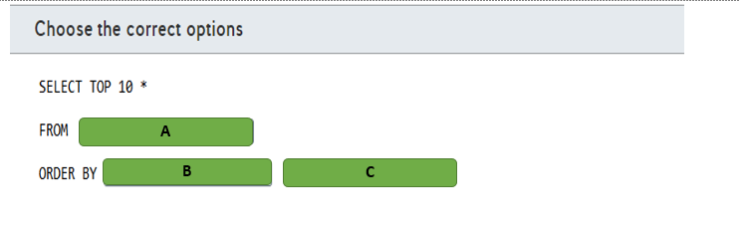

A)

1. Sys.dm_pdw_exec_requests
2. DimEmployee, FactWorkResults

B)

1. Submit_time
2. Total_elapsed_time

C)

1. ASC
2. DESC

# Question143 Monitor data processing-

Your company has an Azure HDInsight solution that uses an Apache Hadoop cluster to process and analyze data.  
  
Your management reports slowdowns during a specific time window.  
  
You need to provide a monitoring solution that tracks cluster performance issues and alerts your team as soon as possible.  
  
Which two monitoring solutions should you use? Each correct answer presents a complete solution.

Choose the correct answers

Azure Monitor metrics

Azure Monitor Log Analytics

Apache Ambari

HDInsight Cluster REST API

# Question144 Monitor data processing - D

You manage an Azure Stream Analytics job for a real-time log streaming solution.  
  
The logs are consumed by PowerBI to generate a dashboard. Users of this dashboard report that new data is not being streamed to PowerBI.  
  
You troubleshoot this issue and discover that the Stream Analytics job stopped unexpectedly.  
  
You need to configure an alert to monitor this issue.  
  
Which metric or activity log should you implement for this alert?

Choose the correct answer

Streaming Units (SU) percentage utilization

Runtime Errors

All Administrative operations

Output Events

# Question145 Monitor data processing-

Your company uses an Azure Stream Analytics job for a streaming solution. The job resource in Azure Portal is named FraudAnalysis.  
  
Other services in this solution send diagnostic logs to an Azure Monitor Log Analytics workspace. This Log Analytics workspace resource is named LogWorkspace.  
  
Both the Log Analytics and the Stream Analytics job are provisioned in a resource group named Production.  
  
You need to complete the PowerShell command to integrate the job diagnostic logs with Azure Monitor to correlate log data with other services.  
  
How should you complete the PowerShell command? To answer, select the appropriate options from the drop-down menus.

Choose the correct options

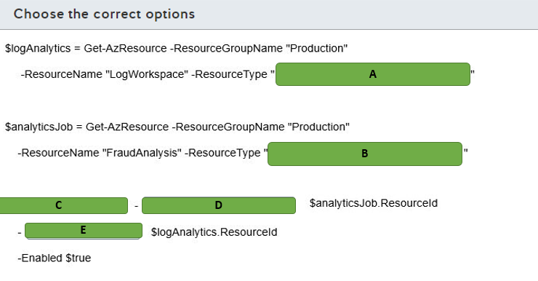

A)

1. Microsoft.Insights/diagnosticSettings
2. Microsoft.OperationalInsights/workspaces
3. Microsoft.StreamAnalytics/streamingjobs

B)

1. Microsoft.Insights/diagnosticSettings
2. Microsoft.OperationalInsights/workspaces
3. Microsoft.StreamAnalytics/streamingjobs

C)

1. Add-AzLogProfile
2. Enable-AzActivityLogAlert
3. Set-AzDiagnosticSetting

D)

1. ResourceId
2. StorageAccountIdWorkspaceId

E)

1. ResourceId
2. StorageAccountId
3. WorkspaceId

# Question146 Monitor data processing - D

Your team manages a data pipeline in Azure Data Factory.  
  
This pipeline is executed every week on Sunday and moves data to an Azure SQL Data Warehouse that is used by the whole company.  
  
You have the following monitoring requirements for this data pipeline:

* If a pipeline run fails, your team needs to be notified so it can remediate the problem.
* Pipeline run metrics from the last 90 days must be stored for analytics and historical data.

You need to implement a monitoring solution to satisfy these requirements with minimal implementation efforts.  
  
Which solution should you use?

Choose the correct answer

Azure Data Factory Monitor

Azure Data Factory REST API

Azure Monitor

.NET Software Development Kit (SDK)

# Question147 Monitor data processing-

You manage an Azure Stream Analytics job to analyze banking system transactions for fraud detection.  
  
You recently optimized the Streaming Unit (SU) consumption for the job by implementing query parallelization. Banking system transactions are expected to increase radically during an upcoming big sales event.  
You need to create an alert if SU consumption is higher than 80 percent.  
  
How should you configure the alert? To answer, select the appropriate options from the drop-down menus.

Choose the correct options

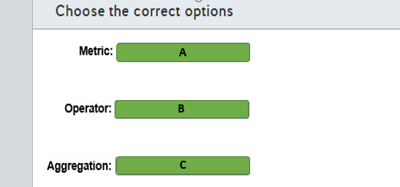

A)

1. Input events
2. Runtime error
3. SU % utilization

B)

1. Greater than
2. Less than
3. Less than or equal to

C)

1. Average
2. Maximum
3. Minimum

# Question148 Monitor data processing - D

You create an Azure Data Factory pipeline. You also create a Log Analytics workspace. In Azure Monitor you set the diagnostic settings as shown in the exhibit.  
  
Which tables can you query using KQL in the Log Analytics workspace?

Choose the correct answer

PipelineRuns and ActivityRuns

ADFPipelineRun and AzureMetrics

ADFPipelineRun and PipelineSucceededRuns

AzureDiagnostics and ActivityRuns

ADFPipelineRun, ADFTriggerRun, and ADFActivityRun

# Question149 Monitor data processing-

You create an Azure Data Factory pipeline. You have a Log Analytics workspace.  
  
In Azure Monitor you set the diagnostic settings for the Data Factory as shown in the exhibit.  
  
You need to create a log alert in the Azure portal using Azure Monitor with a KQL query. The query should be executed every 20 minutes and have a time window of 20 minutes.  
  
How should you configure the settings for the alert in Azure Monitor? To answer, drag the appropriate value to each setting. Each value may be used once, more than once, or not at all.

Drag and drop the answers

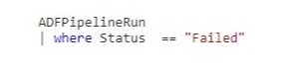

https://pts.measureup.com/web/instances/MUP/assets/images/DP-200/DP-200_71609/fake_5e519808427fe.png

https://pts.measureup.com/web/instances/MUP/assets/images/DP-200/DP-200_71609/fake_5e519808427fe.png



https://pts.measureup.com/web/instances/MUP/assets/images/DP-200/DP-200_71609/fake_5e519808427fe.png

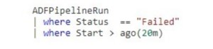

https://pts.measureup.com/web/instances/MUP/assets/images/DP-200/DP-200_71609/fake_5e5198195f630.png

https://pts.measureup.com/web/instances/MUP/assets/images/DP-200/DP-200_71609/fake_5e519823e4372.png

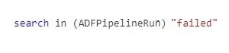

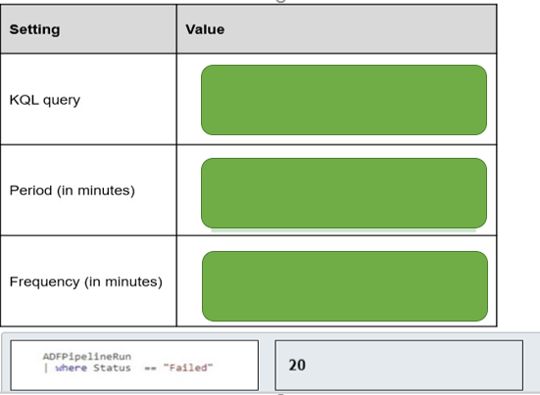

# Question151 Monitor data processing-

You have an Azure resource group named resourcegroup1. This resource group contains the following resources:

* sqlserver1 of type (logical Azure) SQL server
* synapsesqlpool1 of type Synapse SQL pool (data warehouse)

You need to use the Azure portal to set up an alert rule when 80 percent of the maximum resource capacity is used.  
  
How should you configure the alert rule in Azure Monitor? To answer, drag the appropriate value to each alert rule setting. A value may be used once, more than once, or not at all.

Drag and drop the answers

https://pts.measureup.com/web/instances/MUP/assets/images/DP-200/DP-200_72449/fake_5e6273132de2d.png

https://pts.measureup.com/web/instances/MUP/assets/images/DP-200/DP-200_72449/fake_5e6274046905a.png

https://pts.measureup.com/web/instances/MUP/assets/images/DP-200/DP-200_72449/fake_5e627428c8eb1.png

https://pts.measureup.com/web/instances/MUP/assets/images/DP-200/DP-200_72449/fake_5e6273132de2d.png

https://pts.measureup.com/web/instances/MUP/assets/images/DP-200/DP-200_72449/fake_5e6274046905a.png

https://pts.measureup.com/web/instances/MUP/assets/images/DP-200/DP-200_72449/fake_5e627428c8eb1.png

https://pts.measureup.com/web/instances/MUP/assets/images/DP-200/DP-200_72449/fake_5e627327f2c95.png

https://pts.measureup.com/web/instances/MUP/assets/images/DP-200/DP-200_72449/fake_5e62740c2c74d.png

https://pts.measureup.com/web/instances/MUP/assets/images/DP-200/DP-200_72449/fake_5e62743186c51.png

https://pts.measureup.com/web/instances/MUP/assets/images/DP-200/DP-200_72449/fake_5e62743d54ed6.png

https://pts.measureup.com/web/instances/MUP/assets/images/DP-200/DP-200_72449/fake_5e6504830d0e4.png

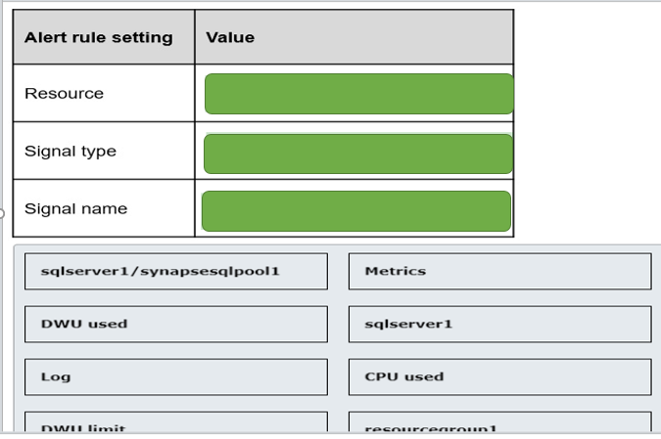

# Question152 Monitor data processing-

You have an Azure SQL Database. Auditing is enabled, using a Log Analytics workspace as a destination.  
  
You need to write a Kusto query giving an overview of the failed login attempts of the last week. The result of the query must show one row per IP address (of the client) and the number of failed logins attempts per IP address.  
  
How should you configure the query? To answer, select the appropriate options from the drop-down menus.

Choose the correct options

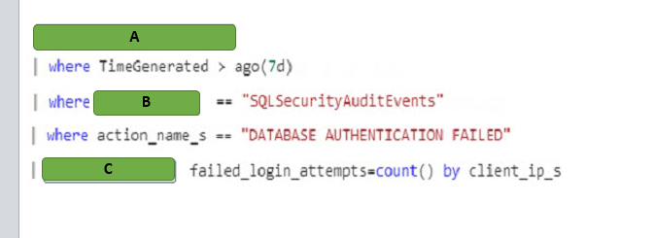

A)

1. AzureDiagnostics
2. SacurityEvent
3. Event

B)

1. Summarise
2. Select
3. project

C)

1. Category
2. $table
3. Event